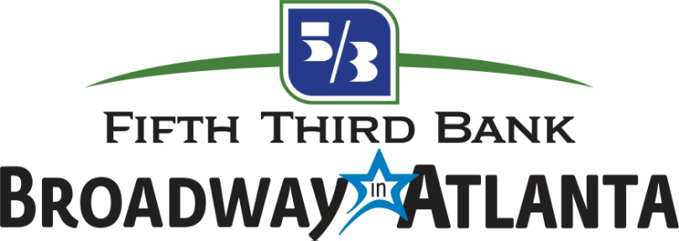

FOR IMMEDIATE RELEASE

THE BLACK THEATRE COALITION /
BROADWAY ACROSS AMERICA
FELLOWSHIP
SPONSORED BY THE JOHN GORE ORGANIZATION

NOW ACCEPTING APPLICANTS THROUGH OCTOBER 15

FELLOWSHIP POSITION AVAILABLE WITH
FIFTH THIRD BANK BROADWAY IN ATLANTA STARTING JANUARY 2022

Atlanta (Oct. 6, 2021) – The John Gore Organization (JGO) the leading presenter, producer, distributor, and marketer of Broadway theater worldwide, has partnered with Black Theatre Coalition (BTC), an organization dedicated to eradicating racial inequities in the theater industry, to create a comprehensive paid fellowship program for Black-identifying undergraduate college juniors, seniors and recent college graduates.

This landmark program, called The Black Theatre Coalition/Broadway Across America Fellowship, sponsored by the John Gore Organization, is now accepting applications through October 15, 2021, for ten paid 14-week part-time positions across the United States with training in the business of commercial theater.

One position will be available in Atlanta, working with the Fifth Third Bank Broadway in Atlanta team in the area of Marketing & PR for Broadway touring shows at the Fox Theatre.

In addition to on-the-job training, the program includes a comprehensive educational curriculum taught by BTC, BAA and other Broadway professionals, providing an invaluable, in-depth education in the business of commercial theater. The program also features a trip to New York City for regional fellows where the cohort will gather for in-person shadowing and networking opportunities.

“At Broadway Across America, we want to take meaningful steps to create change in our industry as it relates to equity, diversity, access and inclusion,” said Russ Belin, Vice President of Broadway in Atlanta. “We believe that one important way to do that is to generate opportunities for students and young professionals to learn about the theater business from the inside, through on-the-job training and opportunities to learn and network with leaders in the industry. We’re excited to partner with Black Theatre Coalition to give these Fellows insight to the wide range of roles that exist in our business off the stage.”

Interested Black-identifying applicants should submit contact information, current school enrollment information, a personal statement, resume and one letter of recommendation at BroadwayFellows.com.

Recognizing the underrepresentation of BIPOC professionals in the commercial theater industry, this program will be dedicated to fostering and preserving a culture of equity, diversity, access, and inclusion. BTC-BAA Fellowships will initially be available in New York, Atlanta, Baltimore, Cincinnati, Fort Lauderdale, Houston and Louisville.

The goal of this fellowship program is to provide undergraduate and postgraduate students with an opportunity to develop the job skills, industry-specific knowledge and network connections necessary to begin a professional career in the commercial theater industry.

At the John Gore Organization, we believe that live theater is for everyone. Everyone means people of all races, ethnicities, gender identities, sexual orientations and people with disabilities. We specifically want to increase participation for those that have been historically underrepresented in the commercial theater industry.

FELLOWSHIP POSITIONS AVAILABLE

Atlanta, GA – Marketing & PR (1 position)
Baltimore, MD – Operations & Marketing (1 position)
Cincinnati, OH – Marketing & PR (1 position)
Fort Lauderdale, FL – Marketing (1 position)
Houston, TX – Marketing & Ticketing (1 position)
Louisville, KY – Ticketing Operations (1 position)
New York, NY– Finance (1 position)
New York, NY – Marketing & PR (1 position)
New York, NY – Operations (1 position)
New York, NY – Ticketing & Business Intelligence (1 position)

For more information and to apply, please visit BroadwayFellows.com.

ABOUT BLACK THEATRE COALITION

Black Theatre Coalition was founded by T. Oliver Reid and Warren Adams during the Summer of 2019. They identified the disparity between the growing inclusivity onstage, versus the almost non-existence of Black professionals off stage. They invited their colleague, Reggie Van Lee, (Chief Transformation Officer of the Carlyle Group) to join them as Co-Founder and Chairman of The Board. Afton Battle is the Executive Strategist and Tamica Clanton is Digital Marketing Strategist.

BTC’s mission is to remove the “illusion of inclusion” in the American Theatre, by building a sustainable ethical roadmap that will increase employment opportunities for Black theatre professionals. Their vision is to reshape the working ecosystem for those who have been marginalized by systemically racist and biased ideology.
Black Theatre Coalition officially filed as a nonprofit 501(c)(3) in June of 2020.
www.BlackTheatreCoalition.org

ABOUT THE JOHN GORE ORGANIZATION

The John Gore Organization is the leading presenter, producer, distributor, and marketer of Broadway theater worldwide. Under the leadership of 14-time Tony-winning theater producer and owner John Gore, its family of companies includes Broadway Across America, Broadway.com, The Broadway Channel, BroadwayBox.com, and Group Sales Box Office. The company presents shows in 48 cities across North America as well as on Broadway, Off-Broadway, London’s West End, Japan, and China. It has won Tony Awards in every producing category as well as numerous other Drama League, Drama Desk and Olivier Awards. The John Gore Organization is committed to supporting theater access and education programs that introduce Broadway to the next generation of audiences and theater professionals. www.johngore.com

# # # #

